**Specific Heat and Newton’s Law of Cooling**

| $c$: specific heat capacity (in joules per gram degree Celsius) | $k$: decay constant | $e$: Euler’s number |
| --- | --- | --- |
| $J$: energy (in joules) | $g$: mass (in grams) | $t$: time (in minutes) |
| $T_{a}$: ambient temperature of the material (in degrees Celsius) | $T_{0}$: initial temperature of the material (in degrees Celsius) | $T_{t}$: current temperature of the material (in degrees Celsius) |

The purpose of this experiment was to find a correlation between the specific heat capacity of a sample of metal (Nickel) and the decay constant of its cooling curve, which was calculated using Newton’s Law of Cooling and the Desmos Graphing Calculator.

The metal sample used in this experiment was Nickel. Nickel is a period 4 transition element on the periodic table with an atomic number of 28. It is a rigid, ductile metal that is silvery white in appearance and often has a shiny metallic luster, although in this iteration of the experiment, the sample used had a duller polish and was in the shape of a rectangular strip. Nickel has a specific heat capacity ($c$) of 0.444 J/g°C.

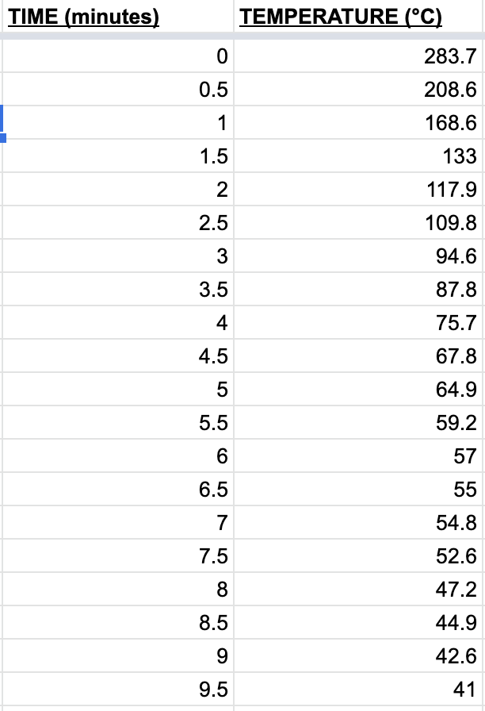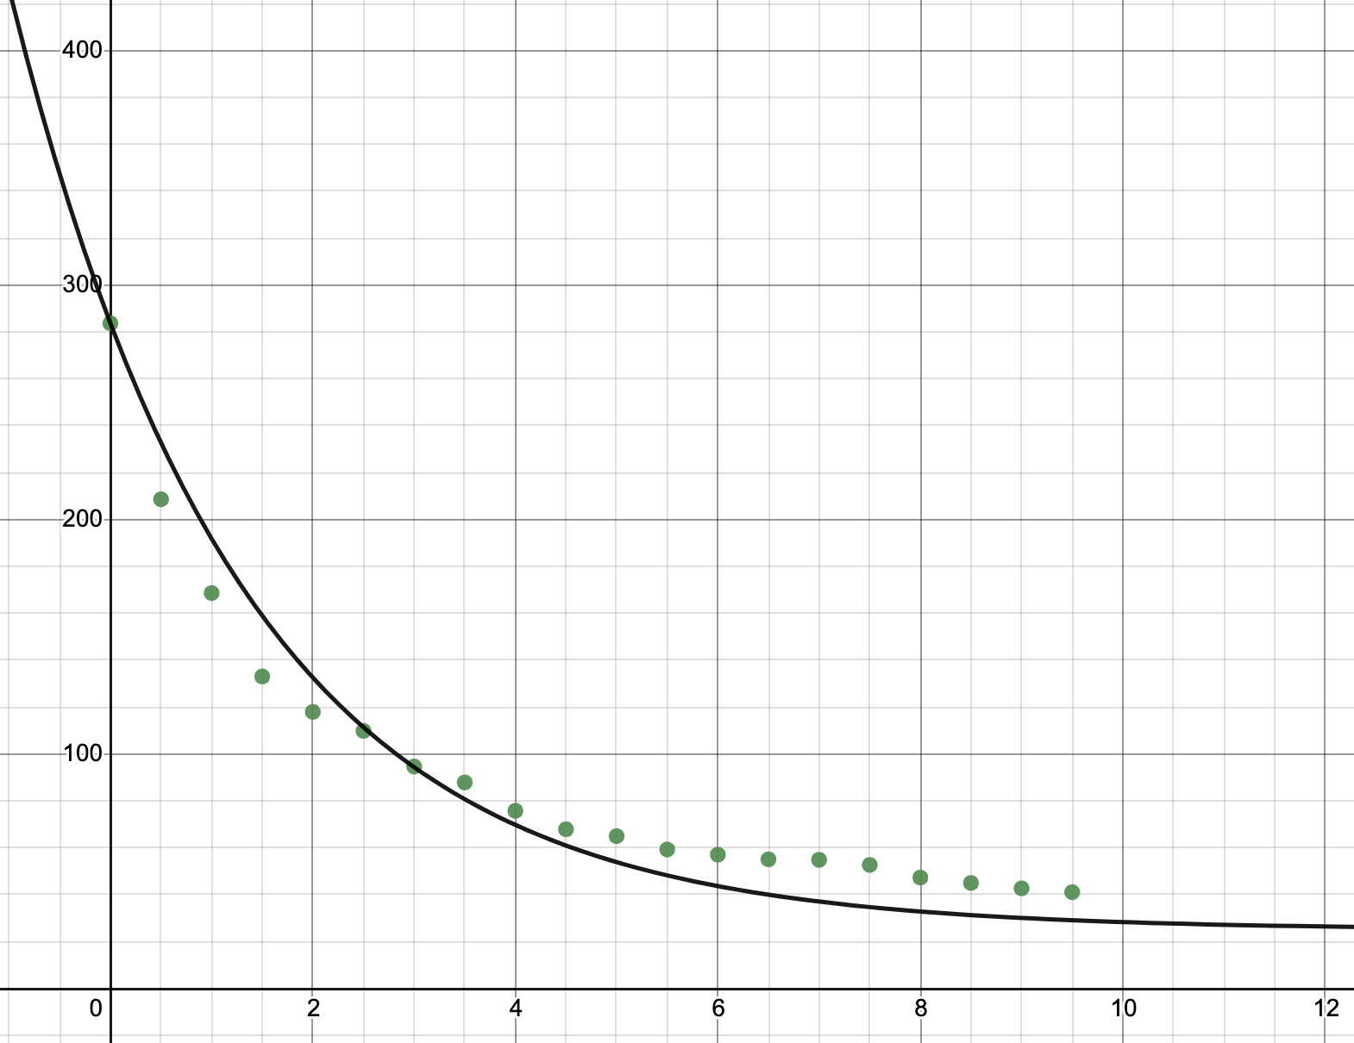

**Fig 1: Data Table for Time vs. Temperature** (left), **Fig 2: Time vs. Temperature for sample of nickel** (right)

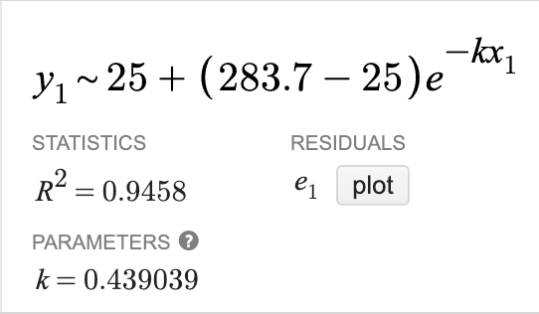

$T_{t}=T_{a}-(T_{0}-T_{a})e^{-kt}$

**Eqn 1: Newton’s Law of Cooling formula**

$y \sim T_{a}-(T_{0}-T_{a})e^{-kx}$

**Eqn 2: Equation for line of best fit**

**Fig 3: Line of best fit with variables replaced**

Before this experiment was done, the Nickel sample was heated over a bunsen burner for 5 minutes. During the experiment, the sample was kept above the bunsen burner with the flame turned off and left to cool slowly, over the course of 9 minutes and 30 seconds. The temperature of the sample was recorded using an infrared thermometer at the start and end of the experiment and at 30-second intervals in between. The initial temperature ($T_{0}$) of the sample, recorded at the start of the experiment, was 283.7°C. The final temperature ($T_{t}$) of the sample, recorded at the end of the experiment, was 41°C. The ambient temperature ($T_{a}$) of the room in which the experiment was conducted was 25°C.

From the variables obtained above, an approximate value of the decay constant, or the rate at which the sample of Nickel cools, can be determined using the equation of the line of best fit (Eqn 2), which is based on the Newton’s Law of Cooling formula (Eqn 1). By replacing the variables with the values above (Fig 3) and placing the new equation along with the experiment data (Fig 1) into Desmos Graphing Calculator, a graph for the line of best fit is produced (Fig 2). Desmos calculated the decay constant ($k$) to be approximately 0.439. A calculation has been performed by hand (Fig 4) using the closest data point (at 3 minutes, when the temperature was recorded as 94.6°C) to verify this calculation.

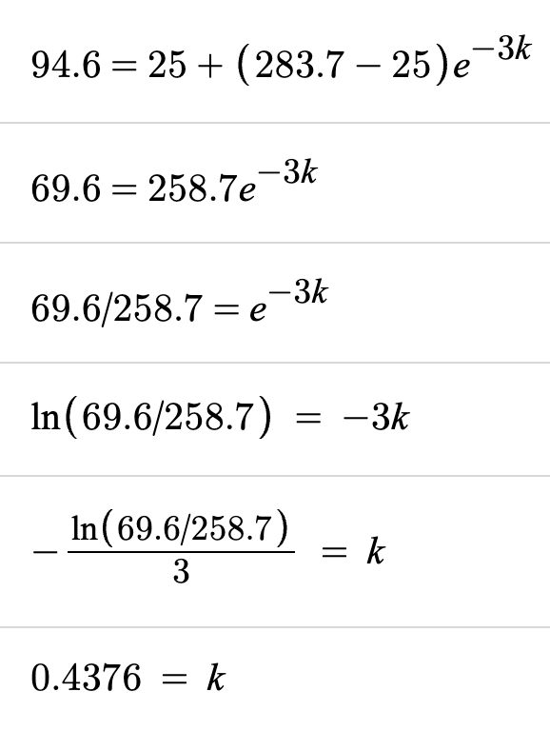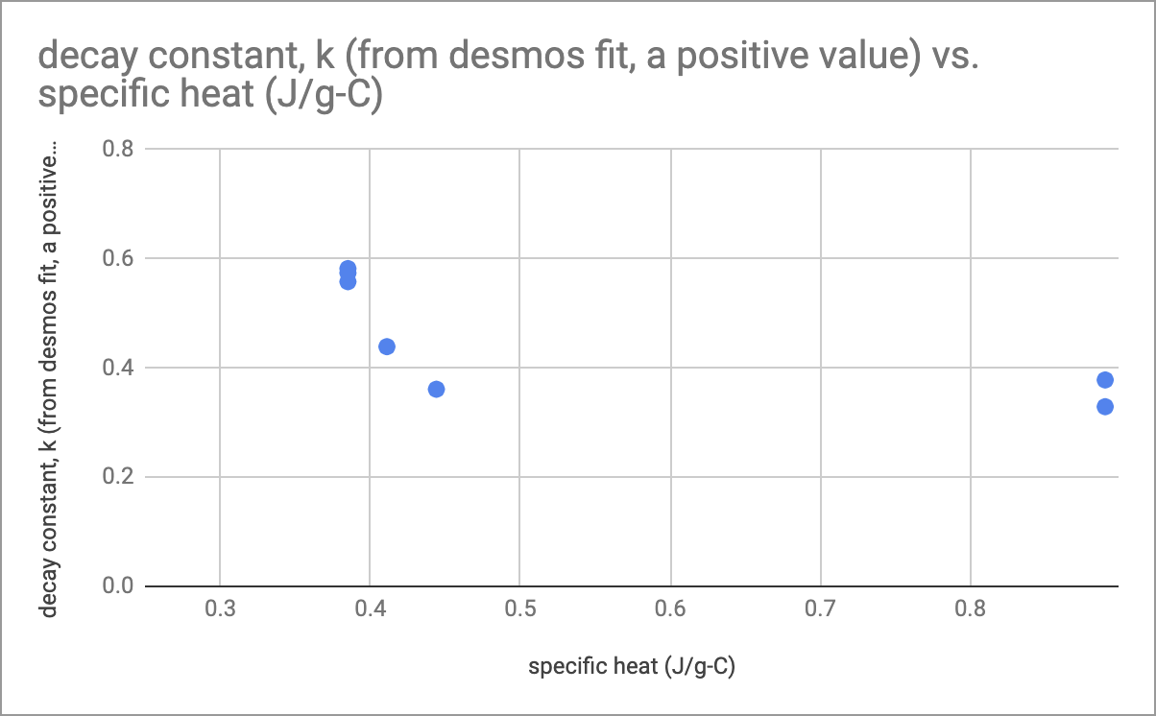

**Fig 4: Decay constant hand calculation** (left), **Fig 5: Scatter plot of *c* and *k* [outliers removed]** (right)

The constant *k* is a constant of proportionality, which changes depending on the equation. In Fig 5, there appears to be an inverse relationship between the specific heat (*c*)and decay constant (*k*). The explanation for this is as follows: as the amount of energy required to heat up the metal increases, the amount of energy that needs to be transferred away from the metal in order to cool the metal to its previous temperature also increases, which means that it will cool slower than another metal over the same amount of time but with a lower specific heat capacity. Thus, as the specific heat increases, the decay constant decreases.

The mathematical explanation is more in-depth, but follows the same principle: if the specific heat (*c*) of the metal in the experiment is low, its initial temperature ($T_{0}$) would be higher than other metals (as all of the metals were heated for the same amount of time). This, in turn, would mean that the current temperature ($T_{t}$) of the metal at any point in the experiment would be greater, on average, than metals with higher specific heat capacities. Thus, $T_{t}$- $T_{a}$ would be greater for this metal than other metals, on average, so this metal would cool far quicker and the decay constant (*k*) for its cooling curve would be greater than that of other metals. Conversely, if the specific heat (*c*) of the metal is high, $T_{t}$- $T_{a}$ would be smaller, on average, and the metal would cool slowly, so the decay constant (*k*) of its cooling curve would be lower than that of other metals.